NITTE MEENAKSHI INSTITUTE OF TECHNOLOGY
Department of Electronics and Communication Engineering
OBJECT-ORIENTED PROGRAMMING USING C++ LAB
TASK 1 REPORT (WEEKS 1–6)
Submission deadline: 16 October 2026
Student Name | R BHANU SAI GANESH
USN | NB25ECE148
Section / Batch | C1
Task Title / Problem Statement | Student class using encapsulation, parameterized constructor, overloading, static member, friend function and overloaded > operator
GitHub Repository URL | https://github.com/Bhanusai56/task-1.git

1. Aim / Objective
To design and implement a C++ program that models a Student using encapsulation, a parameterized constructor, function overloading, a static data member to count students, a friend function and an overloaded > operator that compares two students on the basis of their marks.

2. Problem Statement
Implement a Student class with private data members (name, roll number, marks) that are initialised through a parameterized constructor. The class must provide overloaded display functions, a static member that keeps track of the number of Student objects currently in existence, a friend function that can access private data directly (used here to compute the grade), and an overloaded > operator so that two students can be compared as s1 > s2 using their marks.
The name is stored in dynamically allocated memory, so a copy constructor and destructor are provided to avoid shallow copying and memory leaks.

3. Concepts Used
1. Class and objects with encapsulation (private data, public member functions).
2. Parameterized constructor.
3. Function overloading: display() and display(string).
4. Static data member (count) and static member function (getCount()).
5. Friend function: showResult() accesses private marks and name.
6. Operator overloading: the > operator compares students by marks.

4. Algorithm / Steps
Step 1: Start the program.
Step 2: Create class Student with private members name, rollNo, marks and a static member count.
Step 3: In the parameterized constructor, store the values and increase count by 1.
Step 4: Write two display() functions (with and without a title) - function overloading.
Step 5: Write static function getCount() to return the number of students.
Step 6: Overload the > operator to return true if marks of the first student are greater than the second.
Step 7: Write friend function showResult() to print Passed (marks >= 40) or Failed.
Step 8: In main(), create two students, display them, and print the total count.
Step 9: Call showResult() for both students and compare them using s1 > s2.
Step 10: Stop.

5. Source Code
#include <iostream>
#include <string>
using namespace std;

class Student {
private:
string name;
int rollNo;
float marks;
static int count;

public:

Student(string n, int r, float m) {
name = n;
rollNo = r;
marks = m;
count++;
}

void display() {
cout << name << " | Roll: " << rollNo << " | Marks: " << marks << endl;
}
void display(string title) {
cout << title << ": ";
display();
}

static int getCount() {
return count;
}

bool operator>(Student s) {
return marks > s.marks;
}

friend void showResult(Student s);
};

int Student::count = 0;

void showResult(Student s) {
if (s.marks >= 40)
cout << s.name << " has Passed" << endl;
else
cout << s.name << " has Failed" << endl;
}

int main() {
Student s1("Aarav", 101, 88.5);
Student s2("Diya", 102, 92);

s1.display();
s2.display("Student 2");

cout << "Total students: " << Student::getCount() << endl;

showResult(s1);
showResult(s2);

if (s1 > s2)
cout << "Aarav has higher marks" << endl;
else
cout << "Diya has higher marks" << endl;

return 0;
}

6. Compilation and Execution
Compiler / IDE used: Visual Studio Code with g++ (GCC / MinGW), C++ standard default
Compilation status: ☒ Successful ☐ Errors encountered and corrected
Execution status: ☒ Successful ☐ Not successful

7. Output Screenshot(s)
Program output (terminal):
Aarav | Roll: 101 | Marks: 88.5
Student 2: Diya | Roll: 102 | Marks: 92
Total students: 2
Aarav has Passed
Diya has Passed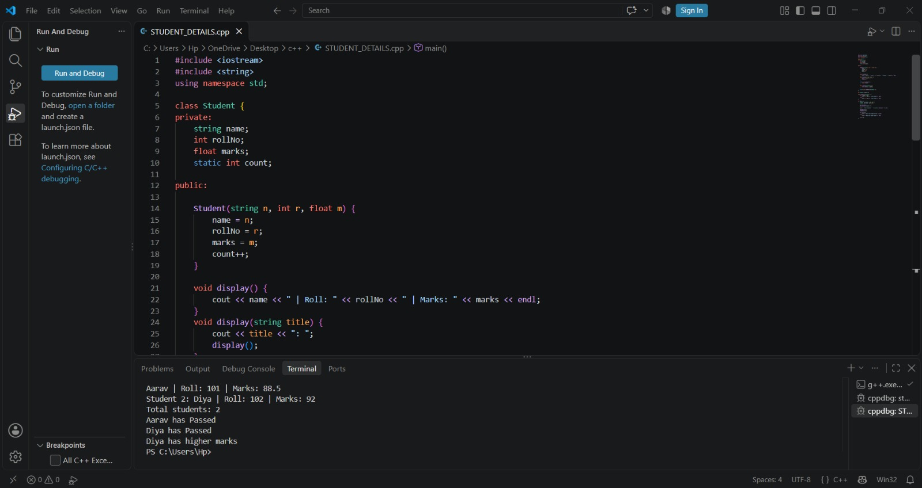
Diya has higher marks

8. Result
The program compiled and executed successfully in VS Code. It created two students, displayed their details using the overloaded display functions, showed the total count as 2 using the static member, printed Passed for both students using the friend function, and found that Diya (92) has higher marks than Aarav (88.5) using the overloaded > operator.

9. Learning Outcome / Reflection
I learned how to use encapsulation with a parameterized constructor, how a static member is shared by all objects and defined outside the class, how a friend function can access private data, and how operator overloading allows comparison of objects like s1 > s2.

10. GitHub Submission Checklist
✓ Report prepared using this template
✓ Source code (.cpp) uploaded
✓ Output screenshot(s) uploaded
✓ Program compiled and executed successfully
✓ Files organized in the correct weekly/task repository
✓ GitHub repository URL included above
Student Declaration: I confirm that this report and program represent my own work.
Student Signature: ___________________________ Date: __________________

